Carpooling System: A Smart and Privacy-Focused Ride-Sharing Solution

Creating a Ride Pool (For Drivers)
Drivers can create a ride pool by entering the following details:
✅ Pickup & Drop Locations – Exact or approximate locations for both starting and ending points.
✅ Departure Time & Date – When the ride will begin.
✅ Available Seats – Maximum passengers allowed.
✅ Vehicle Details – Car model, license plate, and other relevant info.
✅ Preferences & Rules – Music, smoking, pet-friendly, etc.

🔹 Process:
1. The driver posts a new ride with all necessary details.
2. The ride becomes visible to nearby users looking for a ride.
3. Interested riders can send a request to join.
4. The driver can approve or reject requests based on their preferences.

Flow Diagram

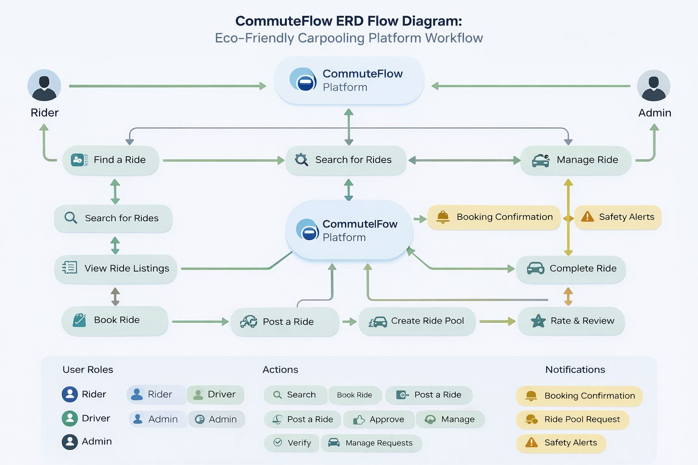

Class Diagram
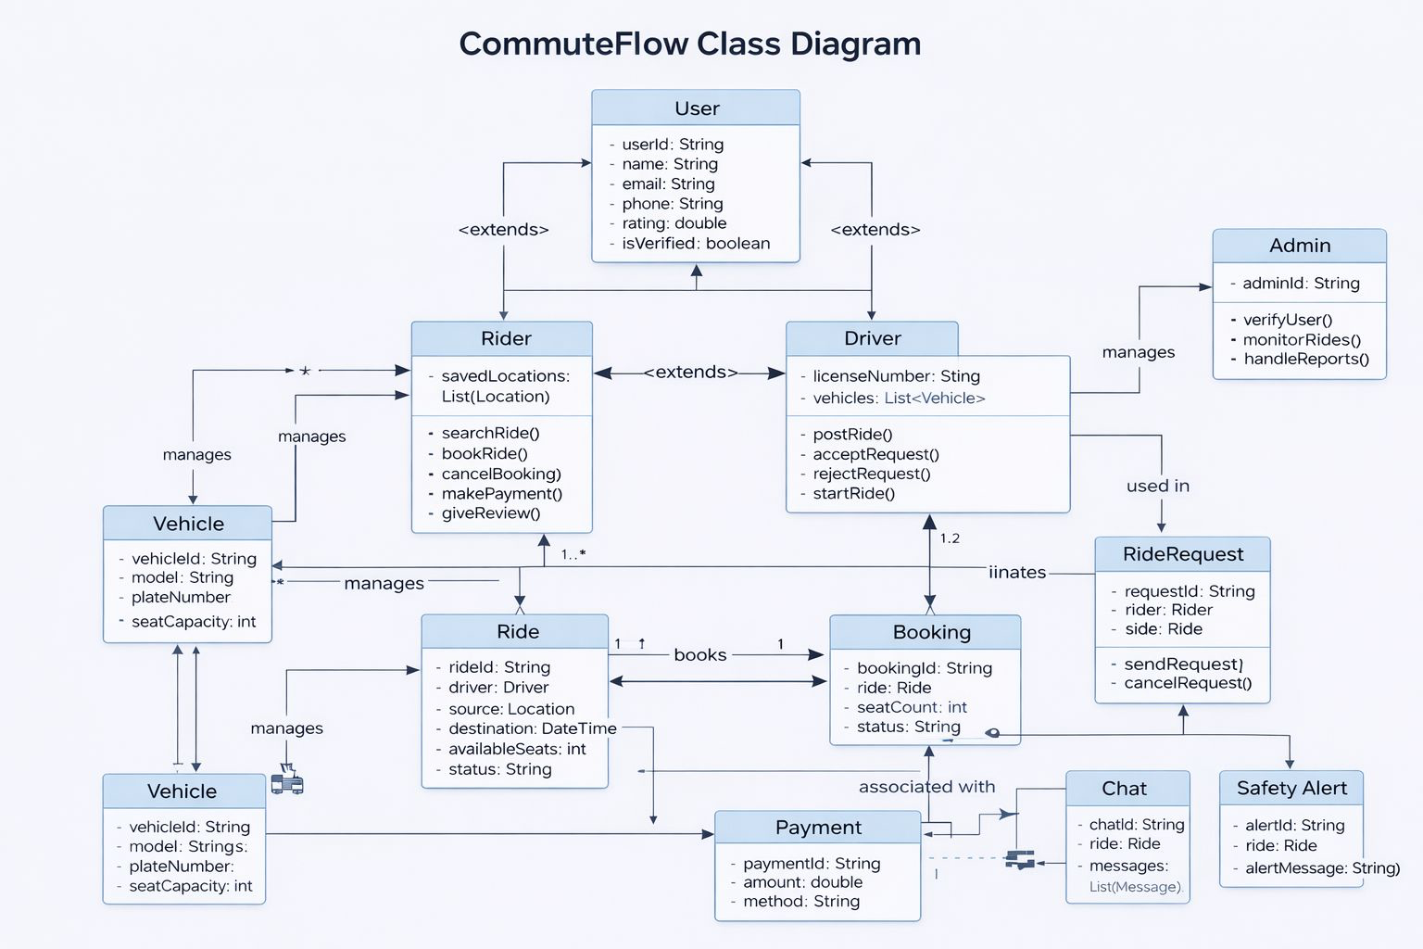
PseudoCode

🔹 1. Main System Flow
START
Display User Interface
IF user is new THEN
SignUp()
ELSE
Login()
GET userRole
IF userRole == Rider THEN
riderFlow()
ELSE IF userRole == Driver THEN
driverFlow()
ELSE IF userRole == Admin THEN
adminFlow()
END

🔹 2. Rider Flow
riderFlow() {
SearchRide()
ViewAvailableRides()
selectedRide = SelectRide()
SendRequest(selectedRide)
WAIT for driver response
IF response == ACCEPTED THEN
makePayment()
ConfirmBooking()
return Ride
ELSE
ShowRejectionMessage()
ENDIF
}

🔹 3. Driver Flow (Added for completeness)
driverFlow() {
CreateRide()
PublishRide()
WAIT for ride requests
FOR each request:
IF Accept THEN
ApproveRequest()
ELSE
RejectRequest()
ENDIF
StartRide()
CompleteRide()
}

🔹 4. Ride Matching Logic
searchRide(source, destination, time) {
FOR each ride IN rideList:
IF ride.source == source AND
ride.destination == destination AND
ride.time == time THEN
RETURN ride
ENDIF
ENDFOR
RETURN "No Ride Found"
}

🔹 5. Booking Flow
ConfirmBooking() {
CreateBooking()
UpdateSeatAvailability()
SendConfirmationNotification()
}

🔹 6. Payment Flow
makePayment() {
DisplayPaymentOptions()
ProcessPayment()
IF paymentSuccess THEN
RETURN "Payment Successful"
ELSE
RETURN "Payment Failed"
ENDIF
}

🔹 7. Safety System (SOS)
triggerSOS() {
SendAlertToAdmin()
ShareLiveLocation()
NotifyEmergencyContacts()
RETURN "SOS Triggered"
}

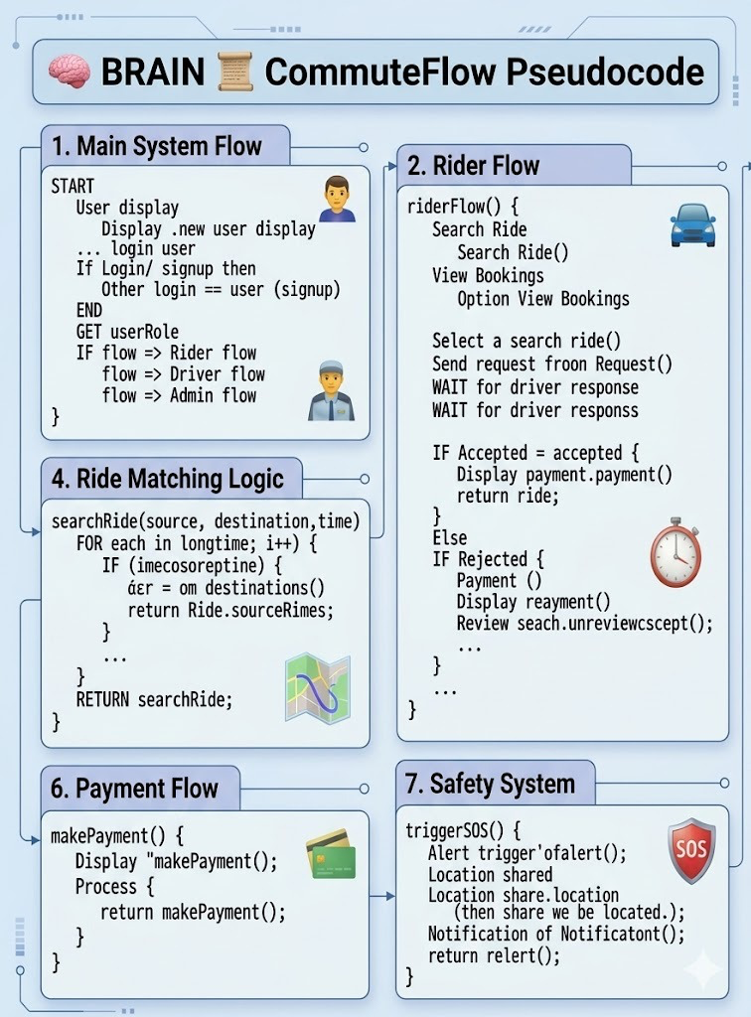

Design & Sample User Interface

